Practice exam

Student select the correct data file (guide below),

Each student write an application for manage the database (by SQLite, can use basic SQLite library or Room persistence library) base the data file like as sample below:

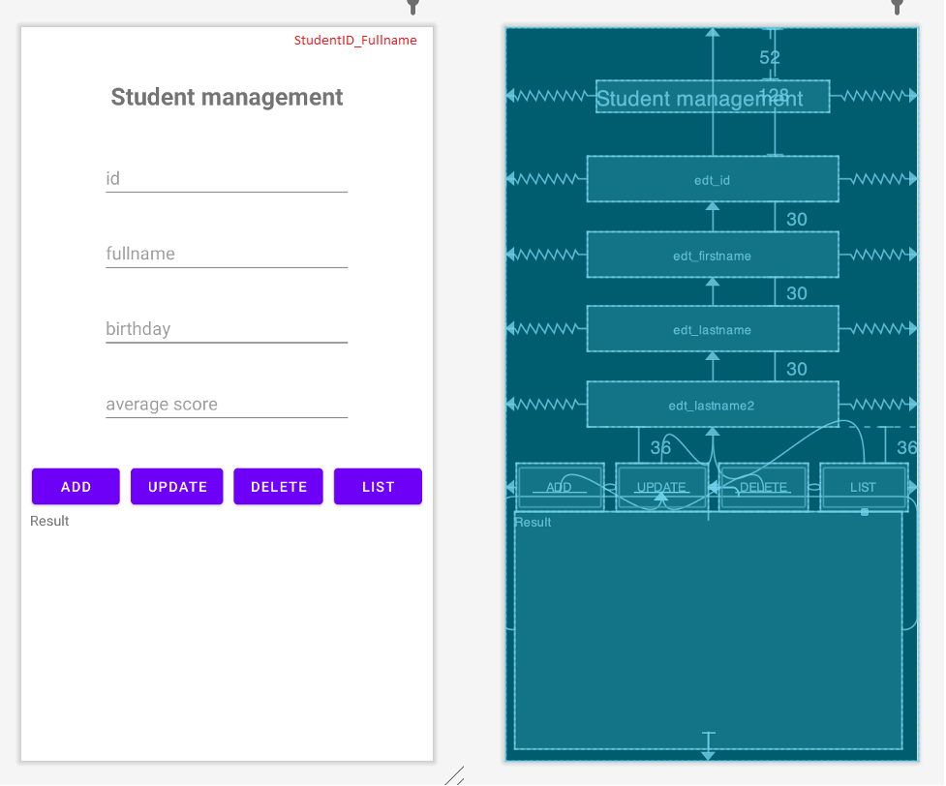

An illustrator for Student manager. Other item manager is similar.

1. Design UI (1.5 point)
2. Design item object (1 point)
3. Add an item with all attributes, text from the editexts, ID is not generated. If ID is existed, click add, the student updated by ID (can use (onConflict = OnConflictStrategy.***REPLACE***in case use Room persistence library) (2.5 points).
4. Update an item (1 points).
5. Delete item (1 point).
6. List: Search by input in editext by id, name or same field. If all of the edittexts is blank, list all item in the recyclerview (contain keyword) (3 point).

**Guide to get correct data file:**

Access the google drive link.

<https://drive.google.com/drive/folders/1Qy6y4Gjrp7iJ_dKnB8vmSKt9vbAoooBk?usp=sharing>

Student base on index’student on the FAP system, select index of assignment, choose the assignment number that corresponds:

*Example: student A has index 3 on the fap.*

*Assess the drive link and select the folder* ***Ass_No3***

Hình thức chấm: vấn đáp, hỏi cách làm, hỏi các kiến thức liên quan, edit theo yêu cầu.

**Note:**

**- Before submiting, clean project, then zip project and name the zip file by the format: Class_StudentID_FullName.zip**

**- Don’t cheat and do the best by yourself**

**- Keep in mind:**

**Cheat: score 0.**

**missing file score 0.**

**wrong submission format, score 0**